- Assignment 1:
Truth table of : AND

A |  | B | A AND B
0 | 0 |  | 0
0 | 1 |  | 0
1 | 0 |  | 0
1 | 1 |  | 1

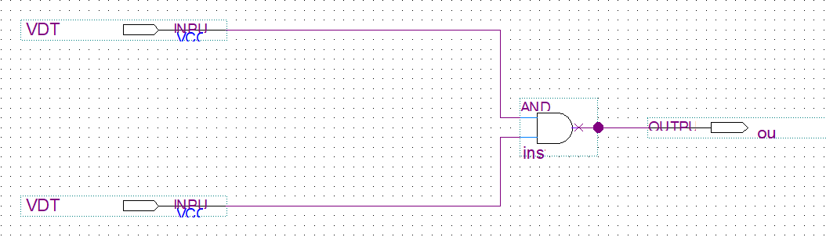

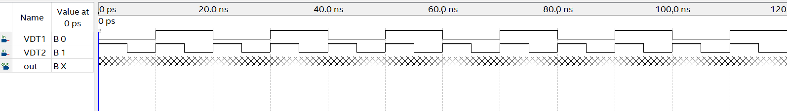

- Assignment 2:
Truth table of : OR

A | B |  | A OR B
0 | 0 | 0
0 | 1 | 1
1 | 0 | 1
1 | 1 | 1

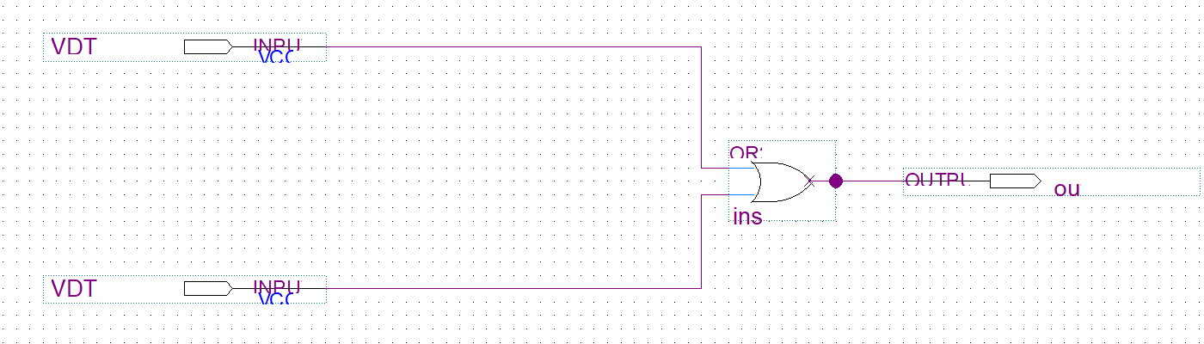
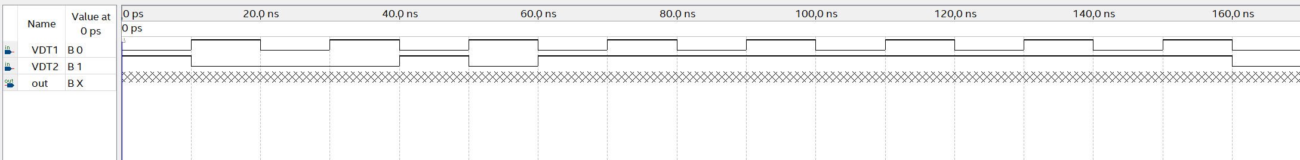

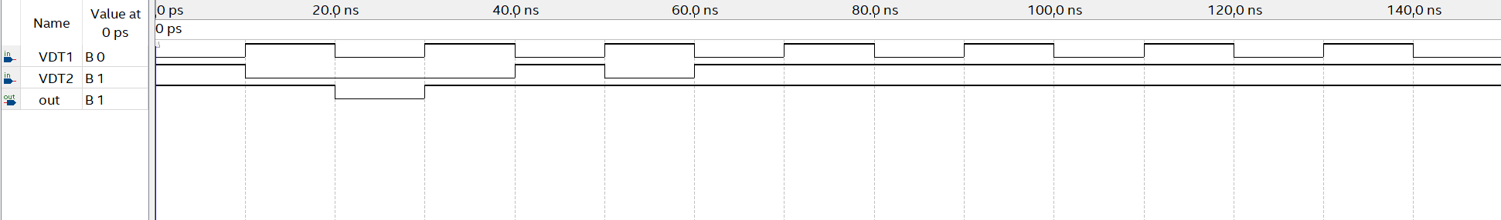

3.Assignment 3:
Truth table of : NAND
A | B | A NAND B
0 | 0 | 1
0 | 1 | 1
1 | 0 | 1
1 | 1 | 0

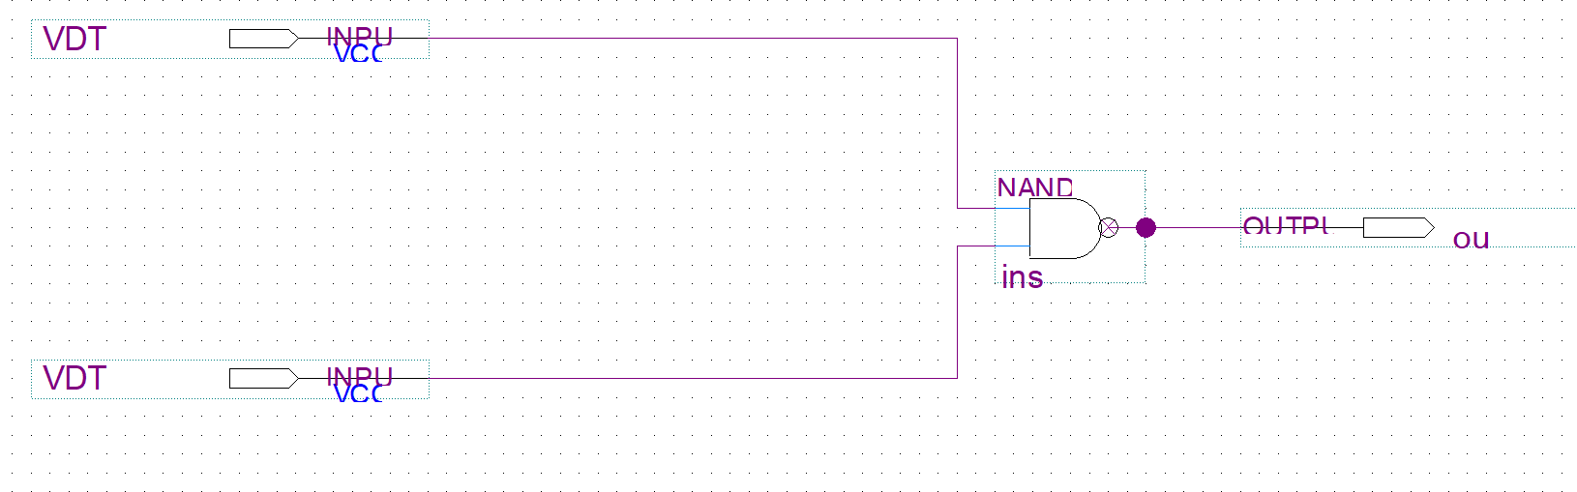

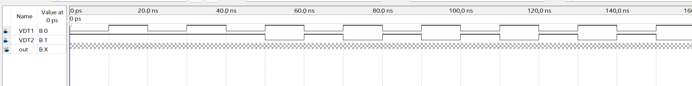

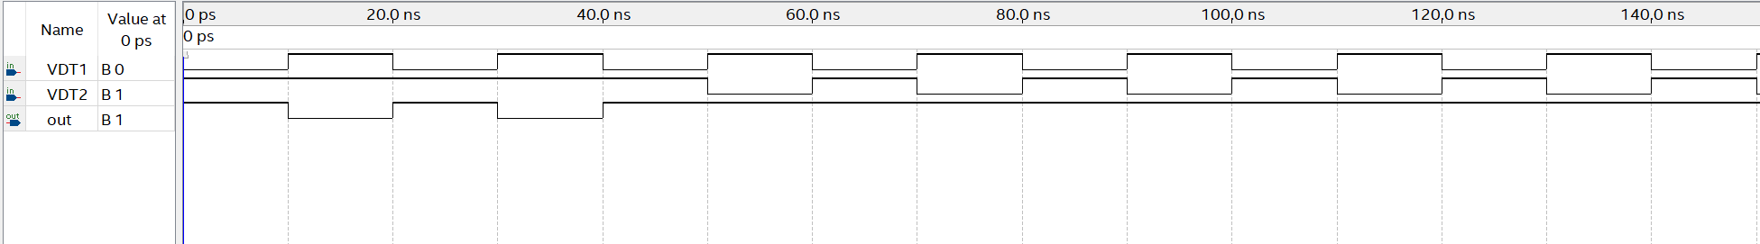

- Assignment 4:
Truth table of : NOR
A | B | A NOR B
0 | 0 | 1
0 | 1 | 0
1 | 0 | 0
1 | 1 | 0

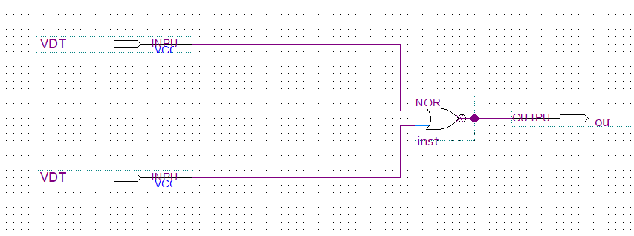

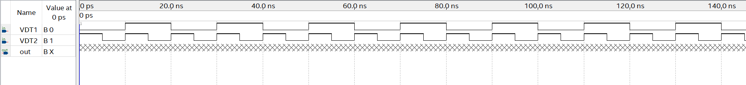

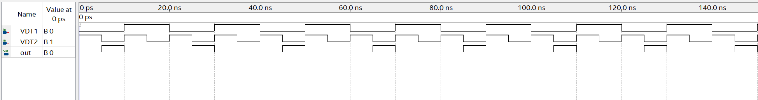
- Assignment 5:
Truth table of : NOT

A | NOT A
0 | 1
1 | 0

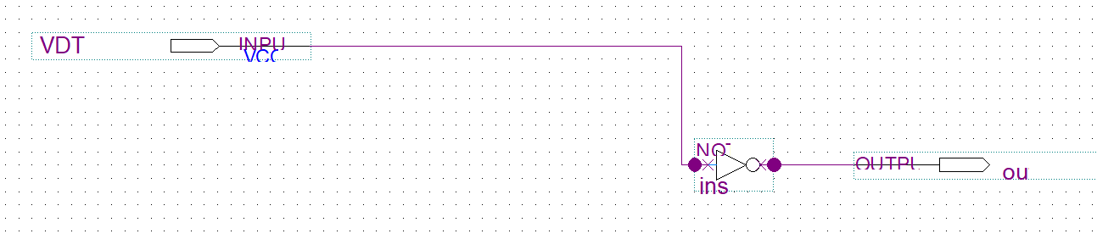

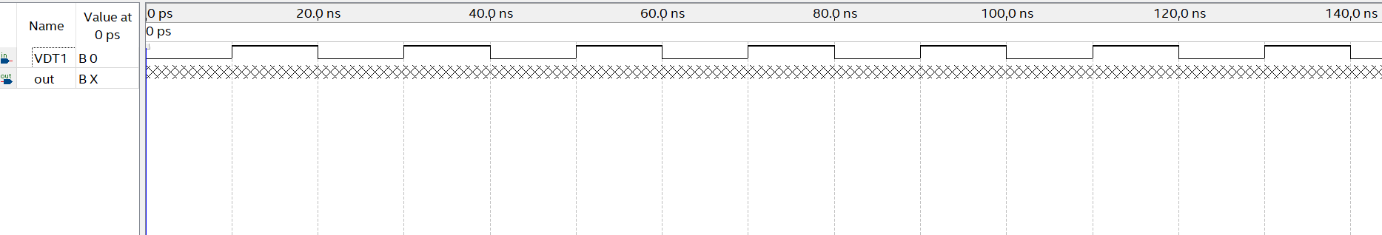

- Assignment 6:
Truth table of : XOR

A | B | A XOR B
0 | 0 | 0
0 | 1 | 1
1 | 0 | 1
1 | 1 | 0

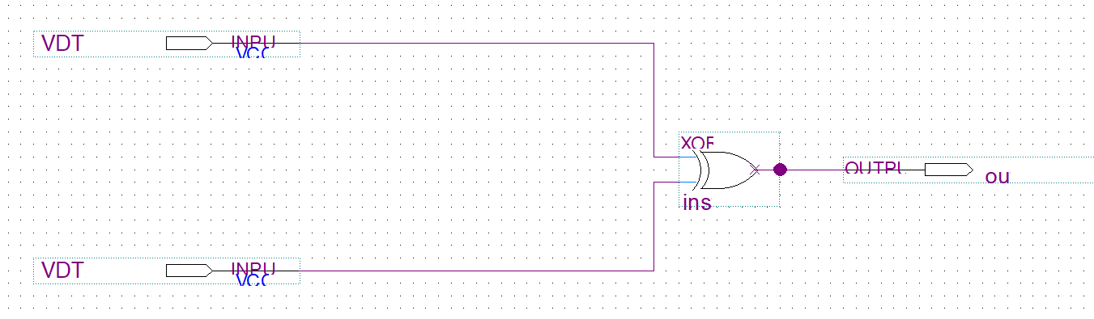

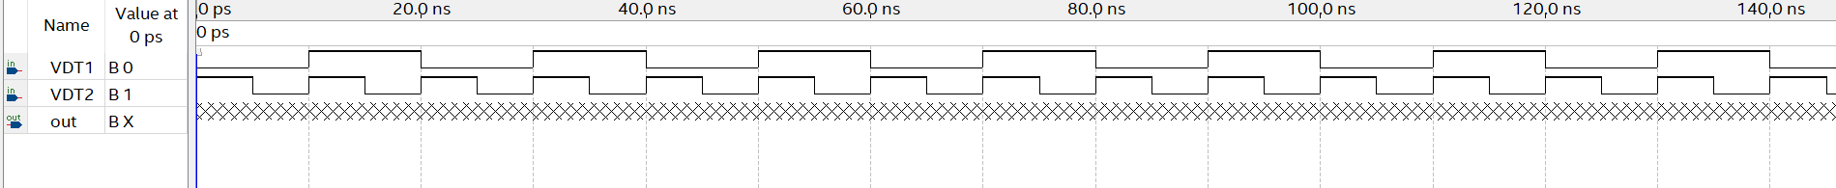

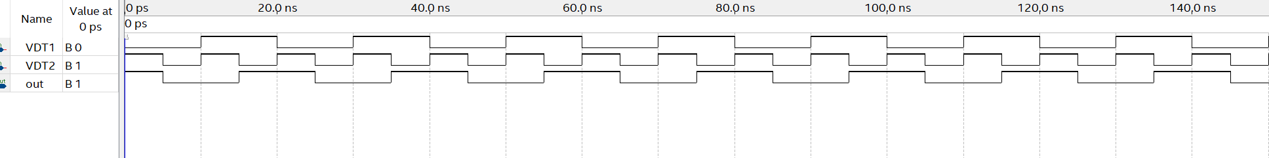
- Assignment 7:
Truth table of : XNOR
A | B | A XNOR B
0 | 0 | 1
0 | 1 | 0
1 | 0 | 0
1 | 1 | 1

